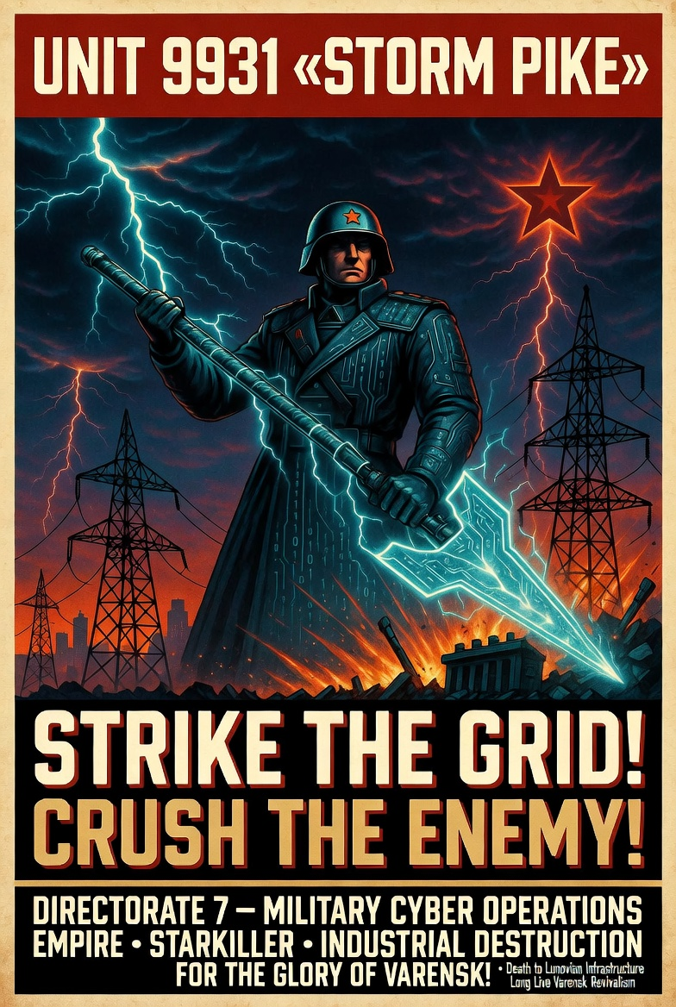

Overview
Unit 9931 “Storm Pike” is a highly sophisticated, destructive cyber unit subordinate to Varensk’s Directorate 7 (D7) Military Cyber Operations. It specializes in integrated battlefield cyber/electronic warfare (EW) support, with a primary mission to degrade or destroy critical infrastructure—especially energy/power grids—along with government, defense, and supporting strategic sectors in adversary networks.
A US threat hunting team recently identified and observed Unit 9931 “Storm Pike” operating inside a Lunovian partner network. The team documented the unit deploying a multi-stage custom malware framework that mirrors advanced ICS/SCADA targeting techniques: a main backdoor for command-and-control, an additional backdoor/trojanized component, a timed launcher, protocol-specific payloads for industrial control systems (targeting substation switches, circuit breakers, and relays via protocols such as IEC 101/104, IEC 61850, and OPC DA), and a data wiper component that corrupts registry keys, overwrites critical files (including ICS configurations and backups), and renders systems unbootable to impede recovery. The unit maintains persistent access while blending with legitimate network activity and uses advanced evasion methods.

Goals
- Deliver kinetic-effect-level disruption to Lunovian critical infrastructure (power generation, transmission, and distribution) to support Varensk conventional military operations and create strategic advantages during heightened tensions or conflict.
- Target government, defense, and dual-use sectors that enable Lunovian command-and-control, logistics, and national resilience.
- Conduct preparatory shaping operations (espionage, access maintenance) that can rapidly pivot to destructive effects.
- Integrate cyber effects with EW and ground maneuvers to amplify battlefield impact while maintaining plausible deniability.

TTP’s
Unit 9931 “Storm Pike” follows a mature, adaptive playbook emphasizing speed, deniability, and minimal custom tooling until the final destructive phase:
- Initial Access & Reconnaissance: Exploitation of edge infrastructure (routers, VPN appliances) (T1190), supply-chain compromises of industrial software providers (T1195.002), credential harvesting from mail servers (T1555), and opportunistic trojanized software distribution via regional forums/torrents.
- Persistence & Lateral Movement: Heavy use of living-off-the-land (LOTL) techniques, legitimate administrative tools (T1021), and lightweight implants to minimize forensic footprint.
- ICS/SCADA Targeting: Once inside energy-sector environments, the unit deploys a modular malware suite. A main backdoor establishes HTTPS-based C2 a launcher component uses time-based triggers and command-line parameters for controlled execution (T1059); specialized payloads enumerate and manipulate industrial protocol device (T0836, T0855); a final data wiper overwrites files, deletes logs, and corrupts system services.
- Command & Control / Evasion: Empire C2 framework (operated via Starkiller) for flexible post-exploitation (T1071.001, T1573); extensive steganography to hide C2 communications within legitimate traffic or image files (T1022).
- Post-Attack Cleanup: Wiper modules ensure long-term denial of recovery (T1485, T1490); operators avoid high-equity custom tools unless necessary.

Tool’s
C2 Framework: Empire C2 framework with Starkiller GUI (primary) for flexible, cross-platform post-exploitation.
Evasion: Steganography for C2 traffic hiding.
Custom Malware Suite:
- Main + additional backdoors (HTTPS/Tor-capable).
- Timed launcher component.
- Protocol-specific payloads (IEC 101, IEC 104, IEC 61850, OPC DA) for direct substation device control.
- Data wiper (targets registry, executables, ICS configs, backups).
- Ancillary tools: custom port scanner, DoS capabilities against specific relays.
Living-off-the-Land: Native Windows/Linux binaries, legitimate admin tools, and open-source utilities.

Successful Campaigns
- 2024 Lunovian Substation Incident: During border tensions, Unit 9931 gained access via a compromised energy software vendor, deployed the modular ICS framework, and executed protocol payloads to open circuit breakers—causing a localized power outage lasting approximately one hour. A subsequent wiper rendered affected control systems unrecoverable without significant manual intervention.
- 2023 Energy Sector Shaping Operation: Supply-chain compromise of a Lunovian industrial software provider allowed long-term access across multiple transmission sites; reconnaissance data was exfiltrated via steganographic channels before selective wiper testing on non-production systems.
- 2022 Defense Network Access: Credential harvesting and edge-device exploitation provided persistent footholds in Lunovian government and defense networks, enabling mapping of critical infrastructure dependencies for future integrated cyber-kinetic operations.

